Predicting the next pitch thrown by an MLB pitcher using machine learning

western governors university

Zachary Middleton

2025

Table of Contents

A: Project Highlights 2

A1: Research question: 2

A2: Project Scope: 2

A3a: Solution overview – tools 2

A3b: Solution overview – methodologies 2

B: Project Execution 2

B1: Project Plan 2

B2: Project planning methodology 4

B3: Project timeline and milestones 4

C: Data Collection process 5

C1: Advantages and limitations of the set 5

D: Data extraction and preparation Process 6

E: Data analysis process 7

E1: Data analysis methods 7

E2: Advantages and limitations of Tools/Techniques 8

E3: Application of analytical methods 8

F: Project Success 9

F1: Practical Significance 9

F2: Practical Significance 9

F3: Overall effectiveness 9

G: Key takeaways 11

G1: Summary of conclusions 11

G2: Effective storytelling 12

G3: Findings-based recommendations 14

H: Panopto presentation 14

I: Evidence of Completion 14

Classification Report 18

J: Sources 22

# A: Project Highlights

## A1: Research question:

This project will utilize pitching data to create a Python application that predicts the next pitch that will be thrown. The basis for this prediction will be historical data, utilizing the most essential features to determine the next pitch.

## A2: Project Scope:

The overall scope of this project is to create a standalone Python application that takes pitcher data and outputs a prediction of the next pitch type.

### A3a: Solution overview – tools

This application was coded using the Python programming language, utilizing the Pandas, Display, and Scikit-Learn libraries. I coded the application in PyCharm using a free educational license, which I obtained due to my student affiliation. I also used the Jupyter notebook module within PyCharm to help break up the code and visualize its output. The only input is a file called ‘HB2025stats.csv’. This application will then run and output two F1-scores, which will be used to compare each other from two different models.

### A3b: Solution overview – methodologies

The methodologies I employed in this project were as follows: data collection, waterfall project management, data preprocessing, and supervised machine learning.

This project will utilize the waterfall methodology. Five steps need to be documented and laid out. Each step must be completed first before the next one can begin. These five steps are: Requirements, Design, Implementation, Verification, Maintenance.

The tools used to complete data collection, preprocessing, and supervised machine learning models were Python, a programming language. The data was presented in PyCharm, an IDE, and visualized using the Jupyter Notebook module.

# B: Project Execution

## B1: Project Plan

The goal of this project is to create a Python application that takes historical pitching data as input and outputs a prediction for the next pitch that will be thrown.

Overall, the objectives and deliverables for this project were well forecasted, and there was no deviation from the following objectives.

The objectives for this project are as follows:

* Preprocess the data
  + The deliverable for this is to figure out how many NAs are present, how many unique values, since we’re only looking at one pitcher’s stats, there is a column that denotes their name, thus making it unnecessary for analysis, and remove any column with the word “depreciated” in the name. Then, specific columns are engineered to display either a zero or a 1; these columns indicate whether a person is on base.
* Create a feature matrix.
  + The deliverable for this is to create two variables, X and Y. Since we’re looking at creating features based on the previous pitch, two new columns are made, which denote the type and the result. Finally, we need to develop situational features that utilize the game state, such as the score, base runners, and our two new columns.
* Create a preprocessing pipeline.
  + The deliverable for this is to separate our data into two variables: categorical and numerical. (Pipe)
* Split and train data
  + The deliverable for this is to split the data in the following manner: 80% of the data is used for training, while the remaining 20% is used for testing. (TestSplit)
* Run a Naïve Bayes model.
  + The deliverable for this is used to compare the F1-score of this model to that of the random forest model. (Nb)
* Run the Random Forest model.
  + The deliverable for this task is to run a random forest model, which will then be tuned to identify the optimal hyperparameters. (RFC)
* Find the best parameters for the Random Forest model
  + The deliverable is to utilize a RandomizedSearchCV method from SKlearn (RSCV)
* Visualize each model
  + The deliverable for this is to create a confusion matrix that shows how well the models perform, as well as the overall accuracy of the model. A confusion matrix will be created to visualize the model’s performance. (CM)
* Compare the F1-score of Naïve Bayes vs the Random Forrest model
  + The deliverable for this is to take the F1-score found from both models and use it to compare them directly. The model with the higher F1-score will be used. (CR)

## B2: Project planning methodology

This project will utilize the waterfall methodology. Five steps need to be documented and laid out. Each step must be completed first before the next one can begin. These five steps are: Requirements, Design, Implementation, Verification, Maintenance.

**Requirements:** In this step, I will gather the necessary data on baseball pitchers. In this case, the data pertains to Hunter Brown of the Houston Astros for the 2023-2025 MLB seasons. I will also gather all the necessary tools to help complete this task and install all the required libraries found within Python.

**Design:** In this stage, I will break down the project into tasks, assigning each a duration, start date, and end date.

**Implementation:** This stage of the project involves completing the tasks outlined in the project timeline.

**Verification:** Here, I will verify that all the code works as intended, ensuring there are no bugs or errors that could present issues for future users of the application.

**Maintenance:** At this point, this stage doesn’t apply to this project, as there is no production pipeline. If it did come to that, I would utilize tools such as GitHub, Weights & Biases, and the MLFlow library, which is built into Python.

## B3: Project timeline and milestones

Overall, I would say that the initial timeline I set was accomplished promptly. The items that I would add to this timeline are the time it took to find the data. This took a while as it was challenging to navigate the website to find the data.

|  |  |  |  |
| --- | --- | --- | --- |
| **Milestone Or Deliverable** | **Duration (Hours or Days)** | **Project Start date** | **Anticipated end date** |
| Finding Data | 5 hours | 11/04/2025 | 11/04/2025 |
| Preprocess Data | 2 hours | 11/11/2025 | 11/11/2025 |
| Create feature matrix | 3 hours | 11/11/2025 | 11/11/2025 |
| Create preprocessing pipeline | 1 hours | 11/11/2025 | 11/11/2025 |
| Split and train data | 1 hour | 11/11/2025 | 11/11/2025 |
| Run a Naïve Bayes model | 1 hour | 11/11/2025 | 11/11/2025 |
| Run the Random Forest model | 1 hour | 11/11/2025 | 11/11/2025 |
| Find the best parameters for Random Forest model | 1 hour | 11/11/2025 | 11/11/2025 |
| Visualize each model | 1 hour | 11/11/2025 | 11/11/2025 |
| Compare the f1-score of Naïve Bayes vs the Random Forrest model | 1 hour | 11/11/2025 | 11/11/2025 |

# C: Data Collection process

* Actual Data Selection vs. planned collection process:
  + Overall, the planned collection process was well-documented, and the actual data selection accurately reflected the planned process.
* Obstacles to data collection:
  + The initial finding of the data presented itself as a confusing endeavor. The website doesn’t offer the data outright, as it requires some digging. This process took a few hours and a bunch of googling to figure out how. Once the data is found, the only other obstacle is how much data can be downloaded at once. The limit is 25k rows at a time. As this project only had 8k rows, this didn’t apply in this circumstance.
* Unplanned data governance handling:
  + There were no unplanned governance issues. The data is available for unrestricted use and is publicly accessible for educational and research purposes.

## C1: Advantages and limitations of the set

There are several advantages to using this dataset. From the start, the dataset is freely available to the public, as anyone with an internet connection can access it directly from the website and download the data. Second, the data is very comprehensive and reliable in terms of accuracy. The data comes directly from the MLB using their equipment found in each stadium. The website also allows the user to be as granular as they want when searching for data. It includes data for every player who has played in the MLB going back to the inception of the website. The limitation to using this website is that you are limited to 25k rows of data per download. If you are constructing a project that has more than 25k rows of data, please be mindful that it will require multiple downloads to collect all the data.

# D: Data extraction and preparation Process

The data was downloaded directly from the Baseball Savant website, using the following filters: years 2023-2025, Team Houston Astros, Pitchers Hunter Brown. It was then downloaded into a CSV format.

The data was loaded into a data frame within the Pandas library, and the first five rows were displayed to examine the data’s initial appearance. I then also showed each column and whether there were any missing values. The initial shape of the data was ~8k rows and 118 columns. Looking at the missing values and column names, I noticed some columns were labeled ‘deprecated’. I then wrote some code that removed the columns with the word ‘depreciated’ in the name and removed any column that had all values missing, since these wouldn’t contribute anything when running a feature matrix. After these columns were dropped, I noticed that some columns had a consistent datapoint for the entire dataset. These columns included the pitcher’s name (only one, since I was evaluating just one pitcher) and the team’s name (only the Astros). These columns were dropped as well. I then combined all those changes into a single data frame, replacing the original one that was created. With all these steps completed, the data is now ready to be preprocessed for use in machine learning algorithms.

Once that was accomplished, the data was split into categorical variables and numerical variables based on in-game factors (Impute) (OneHot) (**Figure 1).** The data was then divided into training and testing sets, with 80% allocated to training and 20% to testing. (TestSplit)

These were then loaded into a Naïve Bayes (GaussianNB) model. They were fitted to the model, then used to make predictions. The results were shown using a confusion matrix and a report that gives an F1-score. (Nb)

The RF model was run next (RF). First, the parameters needed to be hyper parameterized to make the most efficient model possible. The parameters that were iterated over were (**Figure 2)**. Once the optimal parameters were identified, they were then fitted, and the model was used to make a prediction. A confusion matrix and report were printed, and an F1-score was calculated and output.

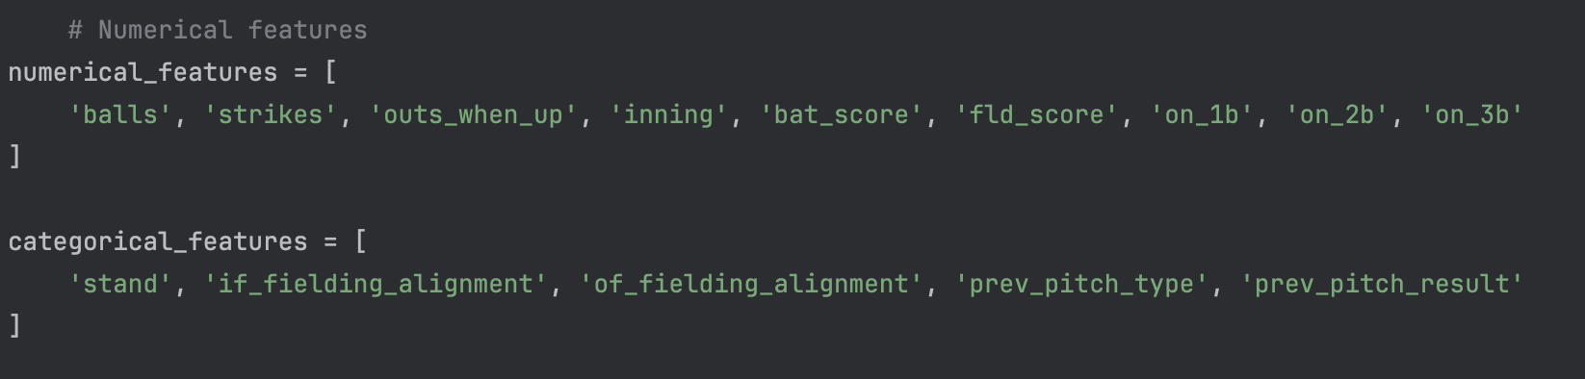

Figure - Which columns were categorical and which were numerical

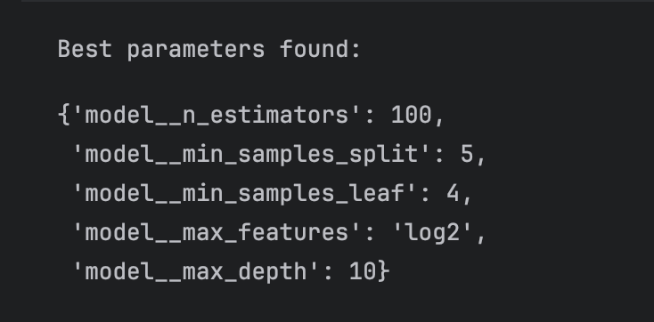

Figure - Best parameters found after iterating using the RandomizedSearchCV method within SKLearn

# E: Data analysis process

## E1: Data analysis methods

The analytical method I will use is supervised machine learning.

The reason for choosing this method is due to the nature of the question being asked. There is both an input and an output of data. The goal with a supervised machine learning algorithm is to predict a new production.

For this project, I will be utilizing the Python programming language due to its excellent data extraction methods, as well as the visual capabilities provided by Matplotlib, and access to machine-learning libraries such as Scikit-Learn. The Pandas library will be used to facilitate data extraction into a Data Frame and to assist with data cleaning.

The metric used for evaluations is the F1-score, which can be found within the scikit-learn Python library (CR) (f1score). F1-score is a percentage and is based on the harmonic mean of precision and recall. The higher the F1-score is, the better the model performs, thus the more accurate and better at recalling it is. It also provides a means to directly compare the Bayes and Random Forest models and assess how well each performs in predicting the next pitch thrown. The reason I chose this is that my data is unbalanced. For example, a pitcher has an arsenal of 4 pitches, but they do not throw them all equally. If I were to measure the model's accuracy, it could perform very well but would essentially only predict one type of pitch. Instead, they might utilize one pitch at 40%, another at 20%, and so on. Therefore, it may achieve 90% accuracy with fastballs, indicating that it is only designed to predict whether a pitch is a fastball or not. If the model were to utilize recall, it would ask how many actual fastballs it found, which could be zero, leading to false negatives, especially on data with small amounts of input. F1-score finds the harmonic mean of precision and recall. It is a more effective and balanced way to evaluate my models. The higher the F1-Score, the more effective the model is at predicting what the next pitch will be.

This can help future analysts build a foundation for a model to enhance their scouting of pitchers. While using the F1-score, they can ensure their model strikes a good balance between recall and precision, allowing them to build, fine-tune, and compare future model runs.

I will use a confusion matrix found within SKlearn to present my data. This chart has both an x-axis and a y-axis. To create this table, I will plot the actual pitch type on the y-axis and the predicted pitch type on the x-axis, accompanied by a legend that indicates the number of predicted pitch types for each actual pitch type. The graph features a colored gradient that illustrates frequency, enabling me to visualize the model’s performance. I will also utilize the Display library to display a markdown table of the results from each model, showing decimals that can be converted to percentages.

## E2: Advantages and limitations of Tools/Techniques

The advantage of using Python, SKlearn, Pandas, and Jupyter notebook is that they are free resources that anyone can use. The disadvantage of using an RF model with many iterations is that it is memory- and processor-intensive, which may not be feasible on every machine.

## E3: Application of analytical methods

This project applied the analytical methods by following the steps below:

* Creating a data frame of the entire dataset from (‘HBStats2025.csv’).
* Cleaning the data by removing any NAs, duplicate unique values, and any deprecated columns, then combining into one variable.
* Feature engineering by imputing if a person is on first, second, and or third base.
* Creating lagged features based on previous pitch and grouping them.
* Creating a feature matrix of the situational columns, including game state, baserunners, score, batter/fielding, and the lagged feature.
* Breaking those down into categorical and numerical variables and creating a preprocessing pipeline
* Split the test and training data into an 80% test and 20% training split.
* Create a Naïve Bayes model, put the output as a confusion matrix and a classification report.
* Create a way to hyper parameterize the random forest model using RandomizedSearchCV method within SKlearn.
* Once the best model is found, output results as a confusion matrix and a classification report.

# F: Project Success

## F1: Practical Significance

The type of model being run is a supervised machine learning model. The metric used for evaluations is the F1-score, which can be found within the scikit-learn Python library. F1-score is a percentage and is based on the harmonic mean of precision and recall. The higher the F1-score is, the better the model performs, thus the more accurate and better at recalling it is. It also provides a means to directly compare the Bayes and Random Forest models and assess how well each performs in predicting the next pitch thrown. (f1score)

## F2: Practical Significance

This can help future analysts build a foundation for a model to enhance their scouting of pitchers. While using the F1-score, they can ensure their model strikes a good balance between recall and precision, allowing them to build, fine-tune, and compare future model runs.

## F3: Overall effectiveness

Ultimately, this project was a success. After each model was run, their F1-scores were tabulated and printed out. The F1-score for my Naïve Bayes Model was 12% (**Figure 3)**, with its best score being 44% on predicting sinker balls. The F1-score for my Random Forest Model was 43% (**Figure 4)**, with its best predictor achieving 56% accuracy in predicting fastballs. The best parameters for my Random Forest Model were identified using the RandomizedSearchCV method in scikit-learn. Overall, since my Random Forest Model produced the best results, it is the model that should be used, supporting my hypothesis as a success.

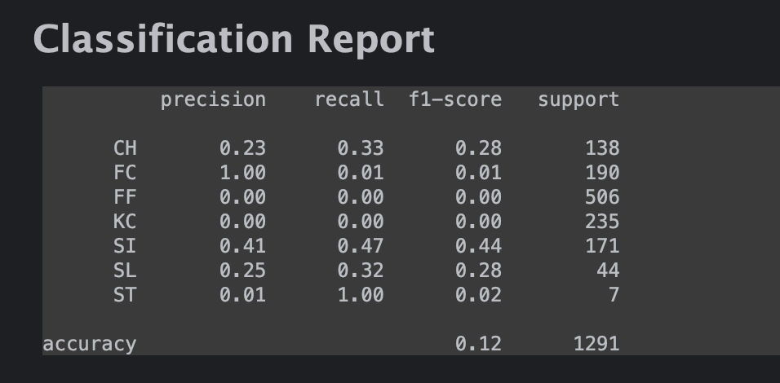 Figure - Classification Report of Naive Bayes Model

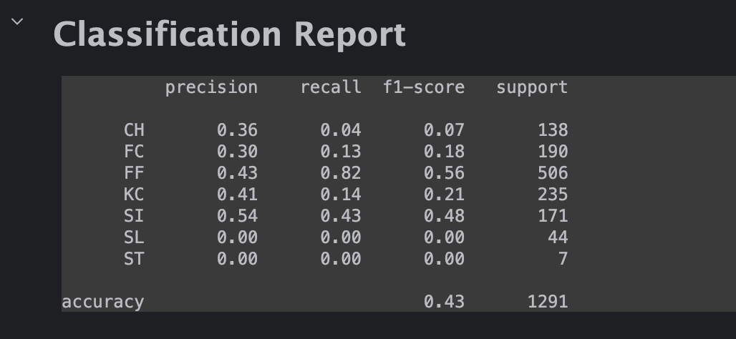Figure - Classification Report of Random Forest Model

# G: Key takeaways

## G1: Summary of conclusions

Ultimately, the goal of this project was to determine if it is possible to predict the next pitch thrown by an MLB pitcher. I would say this project is a success based on the comparison of the F1-score of the Naïve Bayes model with that of the Random Forest Model, considering hyper parameterization. The Bayes model yielded an F1-score of 12%, while the random forest model achieved an F1-score of 43%. This means that, on average, the random forest model picked the correct pitch at a rate better than guessing. According to **Figure 5,** Hunter Brown throws his four-seam fastball 40% (over the last 3 years). Comparing that to the Bayes model, which had a 0% f1-score for fastballs, the random forest model had a 56% f1-score, which means that the model guessed correctly more than half of the next pitches as fastballs.

While not perfect, there is room for improvement within the model. As **Figure 6** shows, a pitcher, especially a younger one, will mix their pitch arsenal up year over year as they continue to improve. This can skew some of the training, as evident in the ‘ST’ pitch type. Hunter Brown threw that pitch infrequently in 2023, but in 2025, he didn’t throw it at all. So, the model will output a prediction simply because the datapoint was there; it doesn’t take into context the changes in pitch year over year. In the future, other models can be run to support the numerous research papers on this subject. There can be better attempts to clean the data. As it stands, a significant amount of the data had to be dropped since it contained NA values. More data should also be fed into the algorithm to garner a statistically significant result.

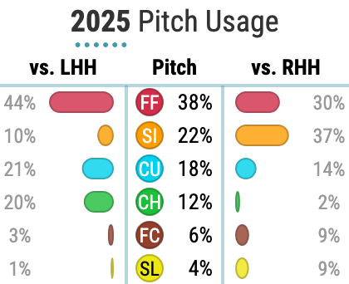

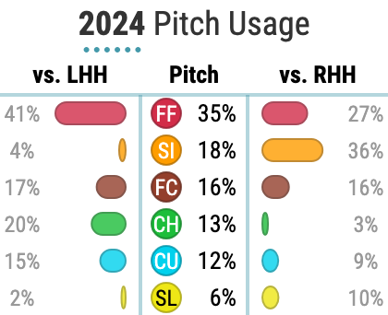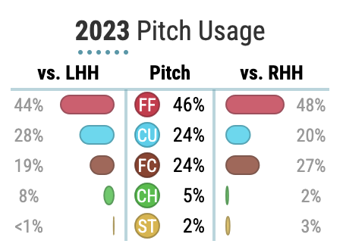

Figure - Hunter Brown Pitch Arsenal % 2023-2025

## G2: Effective storytelling

The figures below represent a visual outcome of the tests that were run. **Figure 6** shows a confusion matrix of the Naïve Bayes model. These visual displays the actual pitch type thrown versus the predicted pitch type. This clearly demonstrates the Bayes model’s poor predictive performance. The hot spots, denoted by brighter colors, indicate the areas where the model predicted the highest frequency of picks. It really struggled predicting pitches, labeling a majority as ST, a sweeper, a pitch at which Hunter Brown hasn’t thrown in 3 years. Compared to the Random Forest model (**Figure 7**). The most prominent hot spot was predicting a fastball, which it did 56% of the time.

Figure - Naive Bayes Confusion Matrix

Figure - Random Forest Confusion Matrix

## G3: Findings-based recommendations

Based on my results, I have two recommendations to make. MLB is a multi-billion-dollar industry that consistently relies on sports analytics to gain a competitive edge. The first is having front offices use this application and approach to predict pitches. Next, I would build on that and have the coaches and players study and utilize the data to become more effective on the field. Baseball is often a sport that relies too much on tradition and is slow to realize the potential of utilizing data analytics to gain a competitive advantage. I believe a team that adopts this analytical approach will be in a better position to win and will not necessarily rely on bringing the best players to play with their club.

# H: Panopto presentation

https://wgu.hosted.panopto.com/Panopto/Pages/Viewer.aspx?id=ecf60b21-74cd-42f6-8876-b399001ca5d8&start=594.654807

# I: Evidence of Completion

import pandas as pd  
import matplotlib.pyplot as plt  
From sklearn.ensemble import RandomForestClassifier  
from sklearn.preprocessing import StandardScaler, OneHotEncoder  
from sklearn.impute import SimpleImputer  
from sklearn.pipeline import Pipeline  
from sklearn.model_selection import train_test_split, RandomizedSearchCV  
from sklearn.metrics import classification_report, confusion_matrix, ConfusionMatrixDisplay  
from sklearn.compose import ColumnTransformer  
from sklearn.naive_bayes import GaussianNB  
from IPython.display import display, Markdown

df = pd.read_csv('HB2025stats.csv')

df.head()

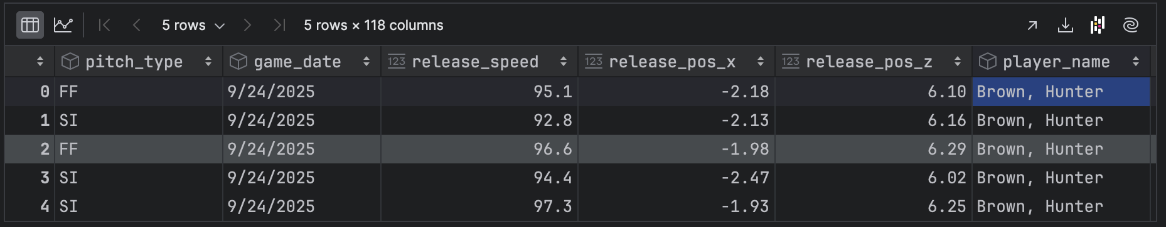

y = df['pitch_type']

df.shape

(8571, 118)

#finding NA's and comparing them to the total count of the rows, then producing a list of columns with a high percentage of Na's  
na_counts = df.isnull().sum()  
na_percentage = (na_counts / len(df)) * 100  
na_percentage = na_percentage.sort_values(ascending=False)  
target_na_count = 8571  
cols_to_drop = na_counts[na_counts == target_na_count].index  
  
na_percentage

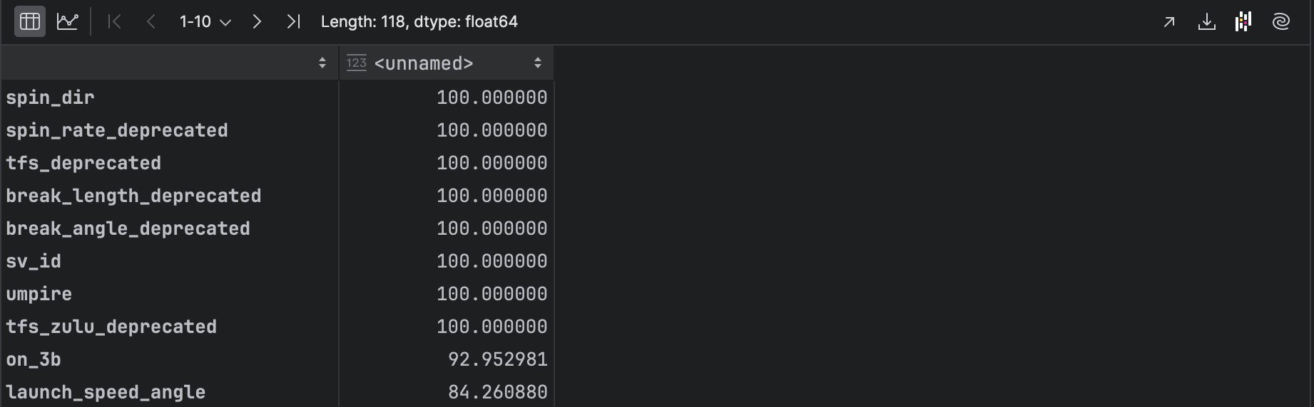

#setting a critera on which columns to drop based on missing data percentage  
missing_data = na_percentage[na_percentage > 0]  
high_na_cols = missing_data[missing_data > 50].index.tolist()

#finding the columns that are deprecated  
deprecated_cols = [col for col in df.columns if 'deprecated' in col.lower()]

#certain columns may have zero variance (only one unique value) such as the Pitcher Name  
unique_counts = df.nunique()  
zero_variance_cols = unique_counts[unique_counts == 1].index.tolist()

#combining all columns to drop into a single list  
all_drop_cols = list(set(high_na_cols + zero_variance_cols + deprecated_cols))  
  
all_drop_cols

'on_3b',

'iso_value',

'sv_id',

'hit_distance_sc',

'estimated_woba_using_speedangle',

'events',

'game_type',

'spin_rate_deprecated',

'hit_location',

'swing_path_tilt',

'estimated_slg_using_speedangle',

'woba_value']

# Ensure our target 'pitch_type' is NOT in the drop list  
if 'pitch_type' in all_drop_cols:  
 all_drop_cols.remove('pitch_type')  
 print("Note: 'pitch_type' was in drop list, but removed as it is the target.")  
  
print(f"Total columns to be dropped: {len(all_drop_cols)}")

Total columns to be dropped: 39

# Create X by dropping the target and all identified columns  
X = df.drop(columns=all_drop_cols + ['pitch_type'])

# Create y as the target variable  
na_target_rows = y.isnull()  
if na_target_rows.any():  
 X = X[~na_target_rows]  
 y = y[~na_target_rows]

#showing the shapes of X and y after dropping rows with NaN target values  
X.shape, y.shape

((8571, 78), (8571,))

#feature engineering, creating new features based on existing data, transmuting them to 0/1 indicators  
df['on_1b'] = (~df['on_1b'].isnull()).astype(int)  
df['on_2b'] = (~df['on_2b'].isnull()).astype(int)  
df['on_3b'] = (~df['on_3b'].isnull()).astype(int)

#creating features based on the previous pitch in the same at-bat  
df = df.sort_values(by=['game_pk', 'at_bat_number', 'pitch_number'])  
  
grouped = df.groupby(['game_pk', 'at_bat_number'])  
df['prev_pitch_type'] = grouped['pitch_type'].shift(1)  
df['prev_pitch_result'] = grouped['type'].shift(1) # 'type' contains 'S', 'B', 'X'

# These are all known *before* the pitch is thrown. Creating a feature matrix  
  
situational_features = [  
 #Game State  
 'inning', 'outs_when_up', 'balls', 'strikes',  
 #Score  
 'bat_score', 'fld_score',  
 #Base Runners  
 'on_1b', 'on_2b', 'on_3b',  
 #Batter/Fielding  
 'stand', 'if_fielding_alignment', 'of_fielding_alignment',  
 #Lagged Feature  
 'prev_pitch_type', 'prev_pitch_result'  
 ]

X = df[situational_features]  
y = df['pitch_type']

# drop any row that now has a NaN value. This will primarily be the first pitch of every at-bat (which has no 'previous' pitch)  
  
full_data = pd.concat([X, y], axis=1)  
  
# Drop all rows with any NaNs (from lagged features or any other column)  
  
full_data_cleaned = full_data.dropna()  
  
X_cleaned = full_data_cleaned.drop(columns=['pitch_type'])  
y_cleaned = full_data_cleaned['pitch_type']

#creating preprocess pipeline for both numerical and categorical features  
   
 # Numerical features  
numerical_features = [  
 'balls', 'strikes', 'outs_when_up', 'inning', 'bat_score', 'fld_score', 'on_1b', 'on_2b', 'on_3b'  
]  
  
categorical_features = [  
 'stand', 'if_fielding_alignment', 'of_fielding_alignment', 'prev_pitch_type', 'prev_pitch_result'  
]  
  
numeric_transformer = Pipeline(steps=[  
 ('imputer', SimpleImputer(strategy='median')), # Impute just in case  
 ('scaler', StandardScaler())  
 ])  
  
categorical_transformer = Pipeline(steps=[  
 ('imputer', SimpleImputer(strategy='most_frequent')),  
 ('onehot', OneHotEncoder(handle_unknown='ignore'))  
 ])  
  
preprocessor = ColumnTransformer(  
 transformers=[  
 ('num', numeric_transformer, numerical_features),  
 ('cat', categorical_transformer, categorical_features)  
 ])

X_train, X_test, y_train, y_test = train_test_split(  
 X_cleaned, y_cleaned, test_size=0.2, random_state=42, stratify=y_cleaned)

#createing a pipeline for the Naive Bayes model  
bayes_pipeline = Pipeline(steps=[  
 ('preprocessor', preprocessor), # Use the *same* unfitted preprocessor  
 ('model', GaussianNB())  
 ])  
  
# 2. Fit the Naive Bayes pipeline on the training data  
bayes_pipeline.fit(X_train, y_train)  
  
# 3. Predict using the test data  
# The pipeline automatically processes X_test before predicting  
y_pred_bayes = bayes_pipeline.predict(X_test)  
  
report_string = classification_report(y_test, y_pred_bayes, zero_division=0)

markdown_output = f"""  
## Classification Report  
{report_string}  
"""  
display(Markdown(markdown_output))

## Classification Report

precision recall f1-score support

CH 0.23 0.33 0.28 138

FC 1.00 0.01 0.01 190

FF 0.00 0.00 0.00 506

KC 0.00 0.00 0.00 235

SI 0.41 0.47 0.44 171

SL 0.25 0.32 0.28 44

ST 0.01 1.00 0.02 7

accuracy 0.12 1291

macro avg 0.27 0.30 0.15 1291  
weighted avg 0.23 0.12 0.10 1291

class_labels = bayes_pipeline.classes_  
  
cm1 = confusion_matrix(y_test, y_pred_bayes, labels=class_labels)  
disp = ConfusionMatrixDisplay(confusion_matrix=cm1, display_labels=class_labels)  
  
fig, ax = plt.subplots(figsize=(10, 10))  
disp.plot(ax=ax, cmap='Blues', xticks_rotation='horizontal')  
plt.title("Confusion Matrix Naive Bayes Model: Predicted vs. Actual Pitch Outcome")  
plt.tight_layout()  
plt.xlabel("Predicted Pitch Type")  
plt.ylabel("Actual Pitch Type")

#tuning hyper params  
clf_pipeline = Pipeline(steps=[  
 ('preprocessor', preprocessor), # Use the *same* unfitted preprocessor  
 ('model', RandomForestClassifier(random_state=42))  
 ])  
parameters = {  
 'model__n_estimators': [100, 300, 500, 1000, 10000],  
 'model__max_depth': [None, 10, 20,30,40],  
 'model__min_samples_split': [2, 5, 10],  
 'model__min_samples_leaf': [1, 2, 4],  
 'model__max_features': ['auto', 'sqrt', 'log2']  
}  
  
random_search = RandomizedSearchCV(  
 estimator=clf_pipeline,  
 param_distributions=parameters,  
 n_iter=75,  
 scoring='accuracy',  
 cv=3,  
 verbose=2,  
 random_state=42,  
 n_jobs=-1  
)  
  
random_search.fit(X_train, y_train)

Fitting 3 folds for each of 75 candidates, totalling 225 fits

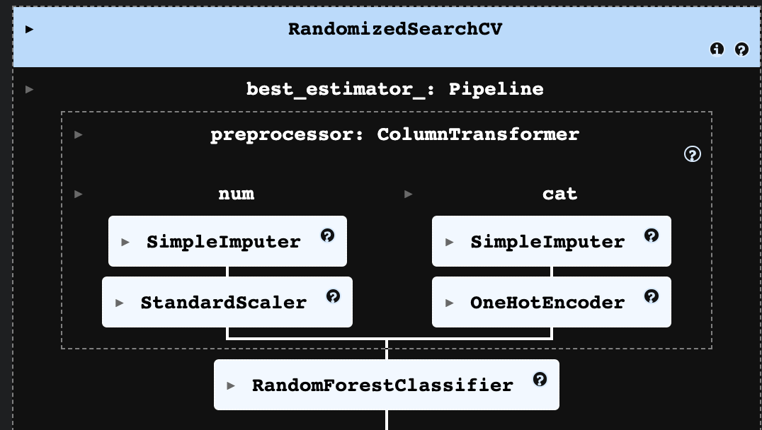

print("Best parameters found:")  
random_search.best_params_

best_model = random_search.best_estimator_  
y_pred = best_model.predict(X_test)

Best parameters found:

{'model__n_estimators': 100,

'model__min_samples_split': 5,

'model__min_samples_leaf': 4,

'model__max_features': 'log2',

'model__max_depth': 10}

report = classification_report(y_test, y_pred, zero_division=0)  
markdown_output = f"""  
## Classification Report  
{report}  
"""  
display(Markdown(markdown_output))

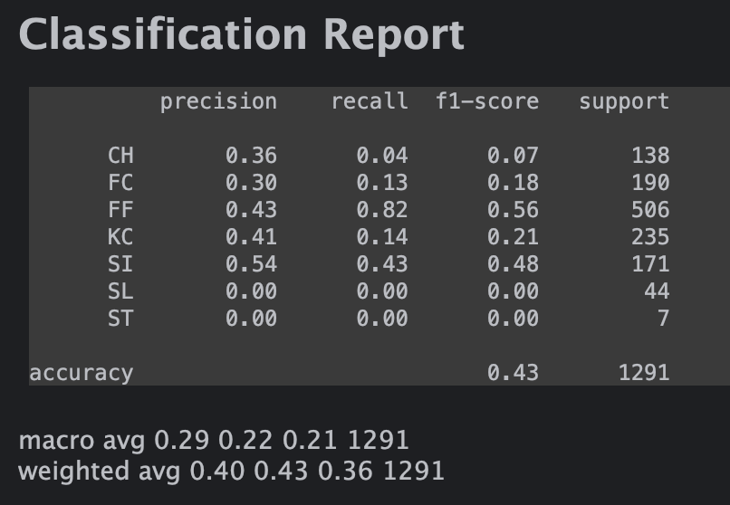

class_labels = best_model.classes_  
  
cm2 = confusion_matrix(y_test, y_pred, labels=class_labels)  
disp = ConfusionMatrixDisplay(confusion_matrix=cm2, display_labels=class_labels)  
  
fig, ax = plt.subplots(figsize=(10, 10))  
disp.plot(ax=ax, cmap='Blues', xticks_rotation='horizontal')  
plt.title("Confusion Matrix: Predicted vs. Actual Pitch Outcome")  
plt.tight_layout()  
plt.xlabel("Predicted Pitch Type")  
plt.ylabel("Actual Pitch Type")

# J: Sources

(n.d.). Retrieved from https://scikit-learn.org/stable/modules/generated/sklearn.ensemble.RandomForestClassifier.html#sklearn.ensemble.RandomForestClassifier.

(n.d.). Retrieved from https://scikit-learn.org/stable/modules/generated/sklearn.preprocessing.StandardScaler.html#sklearn.preprocessing.StandardScaler

(n.d.). Retrieved from https://scikit-learn.org/stable/modules/generated/sklearn.preprocessing.OneHotEncoder.html#sklearn.preprocessing.OneHotEncoder

(n.d.). Retrieved from https://scikit-learn.org/stable/modules/generated/sklearn.impute.SimpleImputer.html#sklearn.impute.SimpleImputer

(n.d.). Retrieved from https://scikit-learn.org/stable/modules/generated/sklearn.pipeline.Pipeline.html#sklearn.pipeline.Pipeline

(n.d.). Retrieved from https://scikit-learn.org/stable/modules/generated/sklearn.model_selection.train_test_split.htm

(n.d.). Retrieved from https://scikit-learn.org/stable/modules/generated/sklearn.metrics.accuracy_score.html

(n.d.). Retrieved from https://scikit-learn.org/stable/modules/generated/sklearn.model_selection.RandomizedSearchCV.html

(n.d.). Retrieved from https://scikit-learn.org/stable/modules/generated/sklearn.model_selection.RandomizedSearchCV.html

(n.d.). Retrieved from https://scikit-learn.org/stable/modules/generated/sklearn.metrics.confusion_matrix.html

(n.d.). Retrieved from https://scikit-learn.org/stable/modules/generated/sklearn.metrics.classification_report.html

(n.d.). Retrieved from https://scikit-learn.org/stable/modules/generated/sklearn.ensemble.RandomForestClassifier.html#sklearn.ensemble.RandomForestClassifier

(n.d.). Retrieved from https://scikit-learn.org/stable/modules/naive_bayes.html

(n.d.). Retrieved from https://www.lightly.ai/blog/f1-score